An Exploration of Longitudinal Changes in Psychological Factors in First and Second Year Asian Students

**Introduction**

The transition period for many college students can prove to be difficult (Fromme, Corbin, & Kruse, 2008). Not only do students have to navigate a new educational system, but they also often have to move locations, have increased freedom and responsibilities, and must manage a new friendship network. Emotional support from families and friends throughout this process appears to be key to help maintain or improve mental health (Azmitia, Syed, & Radmacher, 2013). Additionally, young adults are more likely to discuss issues with their friends than with their family (Tokuno, 1983). However, upon entering university, friendships from high school appear to decline in satisfaction, commitment, rewards, and investments (Oswald & Clark, 2003). Moreover, increased contact with pre-college friends via text messages appears to be correlated with increased levels of loneliness (Igarashi & Yoshida, 2003), while appreciation of new college friends was associated with increased overall adjustment (Tognoli, 2003).

While studies do find that social support is needed to help students successfully transition into college, it is unknown if the increased social support is a cause of or a symptom of students’ adaptation levels. It may be that students who are better adapted attract more friends. Furthermore, all of the reported studies were conducted with students from Western countries. Asia tends to be more collectivist in nature (HA, 1995). In particular, Singapore, the site of this study, has a individualist score of 20, indicating a more group-oriented culture (Hofstede, 2011). Therefore, the patterns of adaptation, friendship, and loneliness may be different for Asian students compared to students from Western countries.

One area of special interest for Singaporean universities is the role of language in social support. In Singapore, students are required to take an approved second language (e.g., Mandarin, Malay or Tamil) besides English, and the exit exams for these languages are often pre-requisites for entry to Singapore universities (MOE, 2014). While all courses at this study’s university are taught in English, many students are bilingual in English and another language, most commonly Mandarin. Accurate communication is a necessary factor in soliciting social support. In research on acculturative stress, researchers have found social support to be stronger among people who speak the same language with the same level of proficiency (Kim, Suh, Kim, & Gopalan, 2012) or at the same level of willingness (Gallagher, 2013). Additionally, given the educational background and prevalence of bilingualism in Singapore, code switching, or the use of more than one language in conversation, is a common feature in their daily oral communication. In order to investigate this potential moderator, we measured self-reported levels of code switching. We hypothesize that code switching may elicit more social support from others, as being able and willing to speak more than one language in a conversation may help clarify meaning, increase accuracy in communication and therefore provide a resiliency factor for some students.

The objective of this paper is to examine the trends and preliminary output for Asian students using a longitudinal dataset. Specifically, we aim to investigate the trends and patterns of college adaptation, loneliness, feelings of community, and number of friends throughout the first year of college, in comparison to students who are in their second year of college. We also posit that code switching may be an important moderator to the changes seen.

**Method**

*Participants*

This study took place at an English-speaking Singaporean university. Thirty four first year and 37 second year students participated in this study as part of a larger project examining social networks in university students. The mean age for the first year students was 20, with a range from 18 to 22 years. The mean age for the second years was 21, with a range from 18 to 23 years. 52 percent of the first year students were male, with 51 percent of the second year self-reporting as male. 62 percent of the first year and 54 percent of the second year students were Singaporean nationals. All participants spoke a language in addition to English, with the most common (92 percent) being Chinese/Mandarin.

*Materials*

We administered the same set of questionnaires at three time points: September 2013, December 2013, and May 2014. Questionnaires were presented to the participants on a computer in a computer lab of the university. All participants finished all three questionnaires. We used the total score of all questions for analyses, unless otherwise noted.

The Code switching Questionnaire was used to collect information about participants’ code switching behavior. This scale was created by our team, and successfully piloted. Participants indicated their frequency of code switching in the past week under different contexts (e.g. face-to-face communication, text messaging, academic setting, casual setting, etc.). This was measured on a 7 point Likert scale. For this study, the average of six questions was used to measure the amount of code switching.

UCLA Loneliness Scale (Version 3) was used to measure loneliness in college students (Russell, 1996). It consisted of 20 items and the total possible score ranged from a minimum of 20 to a maximum of 80, where a higher score indicated a greater sense of loneliness. Additionally, participants were asked to indicate how many friends they had in their class cohort.

Classroom Community Scale consisted of 20 items that measured individual sense of community in a learning environment (Rovai, 2002). The total possible score ranged from 0 to 40 with a higher score indicating a greater sense of community.

Student Adaptation to College Questionnaire (SACQ) was used to measure college adjustment (Baker & Siryk, 1986). It consisted of four subscales (Academic Adjustment, Social Adjustment, Personal- Emotional Adjustment and Goal Commitment/ Institutional Attachment) with a total of 67 items. The total possible score ranged from 67 to 603, and higher scores indicated better adjustment. All means and standard errors for all scales at each time point are available in Table 1 and Figures 1-4.

**Analysis**

*Descriptive*

For the first round of analyses, we examined the differences in the survey variables across time, using two-way ANOVAs (Table 1). For the freshmen students, the SACQ score decreases over time. However, in the second year students, the SACQ score has a negative quadratic shape, dipping in December, and returning to baseline in May. Feelings of community increased across time for first year students, but did not change for second year students. Number of friends increased over time for first year students, but decreased by half for second year students. However, the overall feelings of loneliness did not change for either group.

*Regression*

As part of a larger study, and given the unusual changes in the SACQ scores, we decided to investigate possible moderators to the differences over time. To examine the changes in the SACQ scores over time further, a regression was fitted to the data with the final May SACQ scores as the dependent variable. To create the moderators, the September SACQ score was multiplied with code switching scores to create a continuous moderator. Controlling for baseline scores, nationality, and year in school, code switching appears to moderate the decline from September to May, such that those who code-switch more drop less over time. Standardized beta scores and p-values for the regressions are available in Table 2. Figure 5 demonstrates the differences across a median split for code switching.

**Discussion**

This study aimed to examine the longitudinal changes in SACQ scores, feelings of community, number of friends, and loneliness among first and second year Asian university students. No changes were noted across time for levels of loneliness for either the first or the second year students, indicating that lonely students tend to remain lonely throughout the school year, despite the fact that number of friends increased for first year students and decreased for second year students. However, these levels tended to remain in the middle of the loneliness scale, indicating that students generally felt neither lonely nor not lonely (Table 1).

Feelings of community also did not change significantly over time for the first and second year students (Table 1). However, feelings of community were marginally greater among the first year students than the second year students. This finding was expected, since at this university, first year students take all of their courses together throughout the school year while the second year students begin taking their unique major courses in various subjects.

The first year students indicated a greater number of friends among their cohort class than the second year students. In addition, there was a sudden drop in number of friends in December for the second year students. Given that the second year students had already established their social networks during their respective first year, these differences were a bit unexpected (Table 1). We believe this may be driven by the new course format for second year students. Second year students may be creating new friends outside of their cohort as they take their major courses. However, as we asked the participants to list their friends only from within their own cohort, we may only be capturing changes in friend preference (perhaps due to changes in frequency of interactions) rather than an actual decrease in number of friends.

The SACQ changes for both the first and second year students were the most unexpected and strongest finding for our study. The first year students’ SACQ scores start off high, but steadily decline throughout the school year, while the second year students drop in December, but return to baseline levels in May (Table 1). We hypothesize that this drop in December for second year students may be due to second year students adjusting to changes from first year courses to major courses, and the subsequent changes in their social networks.

To further investigate the changes in the SACQ, a multiple regression was applied to investigate possible moderators to the decline. Code switching appears to create a buffer effect for students, such that adapted students who code-switch frequently do not drop as much as adapted students who do not code-switch frequently. Code switching may provide additional social support opportunities for students, as language barriers are lowered. Peers are then better able to understand and relate to the student who code-switch often, and this additional support may buffer the decrease in adaptation.

Caution should be taken when comparing the first-year students with the second-year students in patterns of college of adaptation, loneliness, feelings of community, and number of friends, as we employed a single year, cross-sectional, longitudinal design. In other words, the first year students are different students from the second year students. Therefore, when the first year students transition into their second year, they may have a different pattern from the second year students in this study. Future research should attempt to conduct a multi-cohort, multi-year study with these measures.

Overall, we demonstrated that college adaptation changes substantially over time for both first year and second year students. Adaptation does not appear to be something that only happens during the transition from high school to university, but rather changes throughout the year. However, social support, which could be produced by code switching, appears to provide some resiliency for students, at least in this cultural context where code switching is prevalent in mutual communication. We suggest that university educators interested in college adaptation should consider monitoring and measuring students throughout the school year, and encourage college students to seek out social support consistent with the languages natively spoken by the student.

WC: 1894/2000

|  |  |  |  |  |  |  |  |  |  |
| --- | --- | --- | --- | --- | --- | --- | --- | --- | --- |
| **Table 1** | | | | | | | | | |
| *Longitudinal Changes in Survey Variables* | | | | | | | | | |
| Variable | | Mean September | | Mean December | Mean May | | Within-Year Across Time Comparisons | | |
| SACQ: First Year | | 392.54 * | | 386.54 | 370.94 * | | F(2,66)=2.95, p=.077  (T1>T2>T3 p = 0.12) | | |
| SACQ: Second Year | | 418.81* | | 387.70 | 414.73* | | F(2,72)=8.54, p<.001; T1>T2, T3>T2, p<.005; T1=T3 | | |
| Class Community: First Year | | 50.34 * | | 51.50 * | 51.24 * | | F(3,99)=0.46, p=.709 | | |
| Class Community: Second Year | | 46.35* | | 44.57* | 46.89* | | F(2,72)=0.70, p=.475 | | |
| Number of Friends: First Year | | 15.77 * | | 11.62* | 14.09* | | X2 = 5.55, p=.134 | | |
| Number of Friends: Second Year | | 9.49* | | 5.78* | 5.84* | | X2 = 7.00, p=.03 T1>T2 | | |
| Loneliness: First Year | | 44.40 | | 43.03 | 43.21 | | F(3,99)=1.31, p=.275 | | |
| Loneliness: Second Year | | 43.89 | | 43.92 | 43.89 | | F(2,72)=0.001, p=.99 | | |
| Note: * indicate significant differences between first year and second year students within the same timepoint. | | | | | | | | | |
| **Table 2** | |  | | |  | |  |
| *May SACQ Regressions* | |  | | |  | |  |
|  | | Beta | | | t | | p-value |
| (Constant) | | -1.363 | | | -3.734 | | 0 |
| Singaporean | | 0.244 | | | 2.611 | | 0.012 |
| Sophomore | | 0.426 | | | 4.778 | | 0 |
| T1 SACQ Full Scale Score | | -0.772 | | | -2.302 | | 0.025 |
| T2 SACQ Full Scale Score | | 0.554 | | | 5.61 | | 0 |
| T1 Code switching | | 0.156 | | | 1.775 | | 0.081 |
| Sophomore*T1 SACQ | | 0.297 | | | 2.414 | | 0.019 |
| Code switching* T1 SACQ | | 0.593 | | | 2.05 | | 0.045 |
| T2 SACQ2 | | 0.125 | | | 1.346 | | 0.184 |

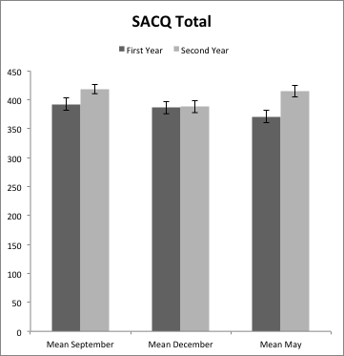

**Figure 1-4:** *Survey Variables Across Time*

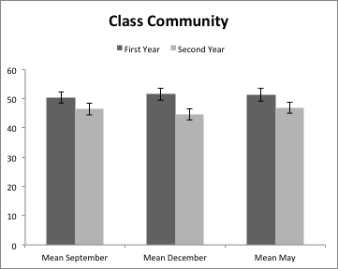

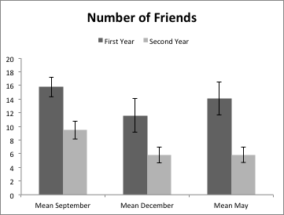

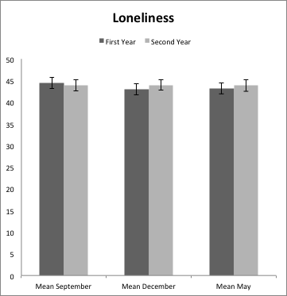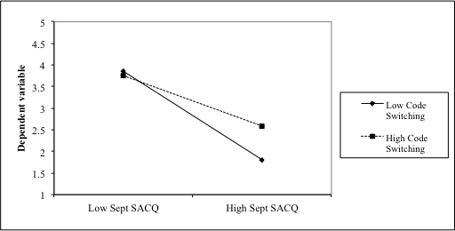

**Figure 5:** *Code switching as a moderator*

May \Adaptation Scores

September Adaptation Scores

**References**

Azmitia, M., Syed, M., & Radmacher, K. (2013). Finding your niche: Identity and emotional support in emerging adults’ adjustment to the transition to college. *Journal of Research on Adolescence*, *23*(4), 744–761. Retrieved from https://search.ebscohost.com/login.aspx?direct=true&db=psyh&AN=2013-39979-013&site=ehost-live&scope=site

Fromme, K., Corbin, W. R., & Kruse, M. I. (2008). Behavioral risks during the transition from high school to college. *Developmental Psychology*, *44*(5), 1497–1504. Retrieved from https://search.ebscohost.com/login.aspx?direct=true&db=psyh&AN=2008-12114-027&site=ehost-live&scope=site

Gallagher, H. C. (2013). Willingness to communicate and cross-cultural adaptation: L2 communication and acculturative stress as transaction. *Applied Linguistics*, *34*(1), 53–73. Retrieved from https://search.ebscohost.com/login.aspx?direct=true&db=psyh&AN=2013-04243-003&site=ehost-live&scope=site

HA, F. I. (1995). Shame in Asian and Western Cultures. *American Behavioral Scientist*. doi:10.1177/0002764295038008007

Hofstede, G. (2011). Dimensionalizing Cultures : The Hofstede Model in Context Dimensionalizing Cultures : The Hofstede Model in Context. *Online Readings in Psychology and Culture*, *2*, 1–26. doi:http://dx.doi.org/10.9707/2307-0919.1014

Igarashi, T., & Yoshida, T. (2003). The effect of the use of mobile phone text messages on freshmen’s loneliness during the transition to college. *Japanese Journal of Psychology*, *74*(4), 379–385. Retrieved from https://search.ebscohost.com/login.aspx?direct=true&db=psyh&AN=2003-09922-009&site=ehost-live&scope=site

Kim, J., Suh, W., Kim, S., & Gopalan, H. (2012). Coping strategies to manage acculturative stress: Meaningful activity participation, social support, and positive emotion among Korean immigrant adolescents in the USA. *International Journal of Qualitative Studies on Health and Well-Being*, *7*. Retrieved from https://search.ebscohost.com/login.aspx?direct=true&db=psyh&AN=2013-18909-001&site=ehost-live&scope=site

MOE. (2014). Mother Tongue Language Policy.

Oswald, D. L., & Clark, E. M. (2003). Best friends forever?: High school best friendships and the transition to college. *Personal Relationships*, *10*, 187–196. doi:10.1111/1475-6811.00045

Tognoli, J. (2003). Leaving Home: Homesickness, Place Attachment, and Transition Among Residential College Students. *Journal of College Student Psychotherapy*, *18*, 35–48. doi:10.1300/J035v18n01

Tokuno, K. A. (1983). Friendship and transition in early adulthood. *The Journal of Genetic Psychology: Research and Theory on Human Development*, *143*(2), 207–216. Retrieved from https://search.ebscohost.com/login.aspx?direct=true&db=psyh&AN=1984-11973-001&site=ehost-live&scope=site